

***Helpful Tips to Prepare for Speaking at AHFE Virtual Conference***

While preparing for our virtual conference, we studied why some virtual sessions and presentations look more professional than others. Aside from the obvious content and technical elements, we realized a successful experience all comes down to the quality and engagement of the speakers — exactly the same as a live event.

*How do you prepare quality presentation? Through top-notch content and delivery.*

**To ensure a professional presentation look and quality, we recommend using proper presenter camera framing and background light. Make sure your webcam is at eye-level.**

**Adjust the Frame**

First and foremost, to ensure a professional look during your virtual conference, you need to use proper camera framing when recording your presentation speech. Make sure your webcam is at eye-level.

If you’re using your laptop’s integrated camera, it can be difficult to get the angle right. If this is the case, try adjusting it on the table to achieve the ideal angle.

If the angle still isn’t perfect, that’s acceptable — but make sure to put yourself in the center of the frame.



**Minimize Surfaces**

It’s also important to minimize the number of surfaces (walls, floor or ceiling) in your frame. Ideally, you should have only one wall behind you.

**Choose a Simple Background**

Regardless of your home decor, you’ll want as little of it as possible in the frame. Why? Because it might be distracting to the point that the viewer’s attention is focused on your wall art and furniture instead of you, which is not good. As a rule of thumb, we suggest putting yourself in front of a single-colored wall. And, if possible, the wall should be white or another lighter color.

**Proper Light**

This is one of the most important steps you must take. I cannot overstate the importance of lighting. Make sure you highlight this section.

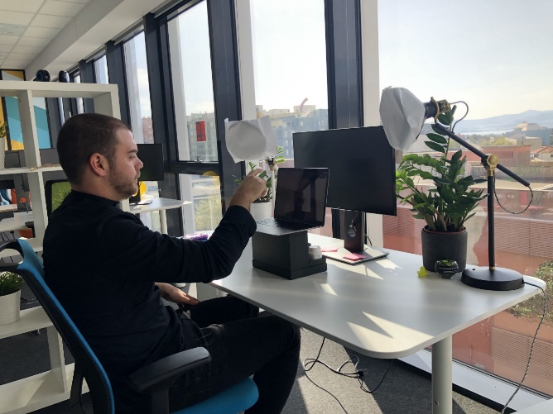

*Perfect setup. Windows in front of you, light or lamps at eye height, and camera elevated.*

**Look at the Camera**

Virtual conferences are supposed to simulate you, as the speaker, talking directly to each viewer. The best way to accomplish this is to look directly into your web camera, not your screen. This gives the viewers a sense that you are making eye contact with them.



**Dress for Success!**

Considering there will a lot of people with various tastes attending a virtual event, we believe business casual attire is the way to go. Above all else, make sure your speakers are wearing pants!