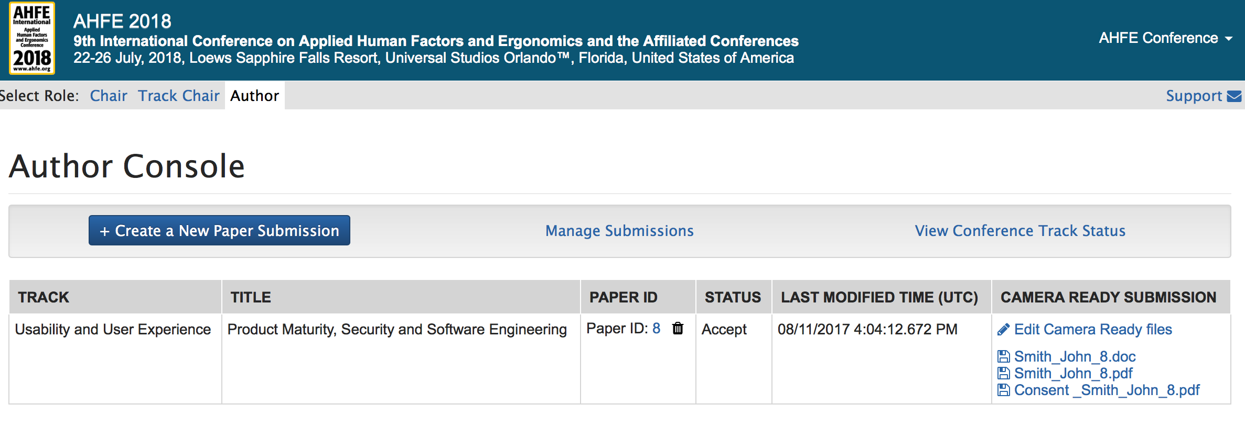

**Important Note:**

**Please upload/submit your Camera Ready formatted paper (The recommended page size of full papers is 6 pages and the maximum is 8 pages) in the AHFE Submission system (**[**https://www.ahfe-cms.org**](https://www.ahfe-cms.org)**). Questions? Please contact AHFE Administrator** [**admin@ahfe.org**](mailto:admin@ahfe.org)

**John Smith**

**Click “Edit” to upload your Camera-Ready Paper (Final Paper)**

**Example for Full Paper File Name Format**

**(**primary author lastname_firstname_PaperID)

**Submission Paper ID**

**Click “Edit” to upload your Camera-Ready Paper (Final Paper)**

**How Can I find my Paper ID ?**

If you have submitted an abstract through the system before then Log in to: (<https://www.ahfe-cms.org>) to find your submission “Paper ID”

***If you haven’t submitted an abstract through the system or assigned a Paper ID previously then after you log in select “Create a new Paper Submission” to obtain a Paper ID.***

**Important Note:**

**Please upload/submit your Camera Ready formatted paper (The recommended page size of full papers is 6 pages and the maximum is 8 pages) in the AHFE Submission system (**[**https://www.ahfe-cms.org**](https://www.ahfe-cms.org)**). Questions? Please contact AHFE Administrator** [**admin@ahfe.org**](mailto:admin@ahfe.org)

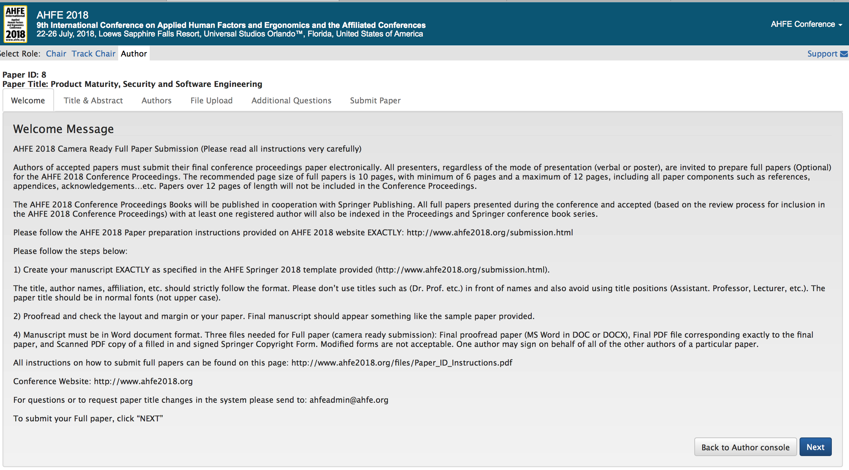

**Welcome Message**

**John Smith**

**Click “Next” to proceed**

**For paper title or author change(s) in the system, please send change(s) along with paper ID to:** [**admin@ahfe.org**](mailto:admin@ahfe.org)

**Important Note:**

**Please upload/submit your Camera Ready formatted paper (The recommended page size of full papers is 6 pages and the maximum is 8 pages) in the AHFE Submission system (**[**https://www.ahfe-cms.org**](https://www.ahfe-cms.org)**). Questions? Please contact AHFE Administrator** [**admin@ahfe.org**](mailto:admin@ahfe.org)

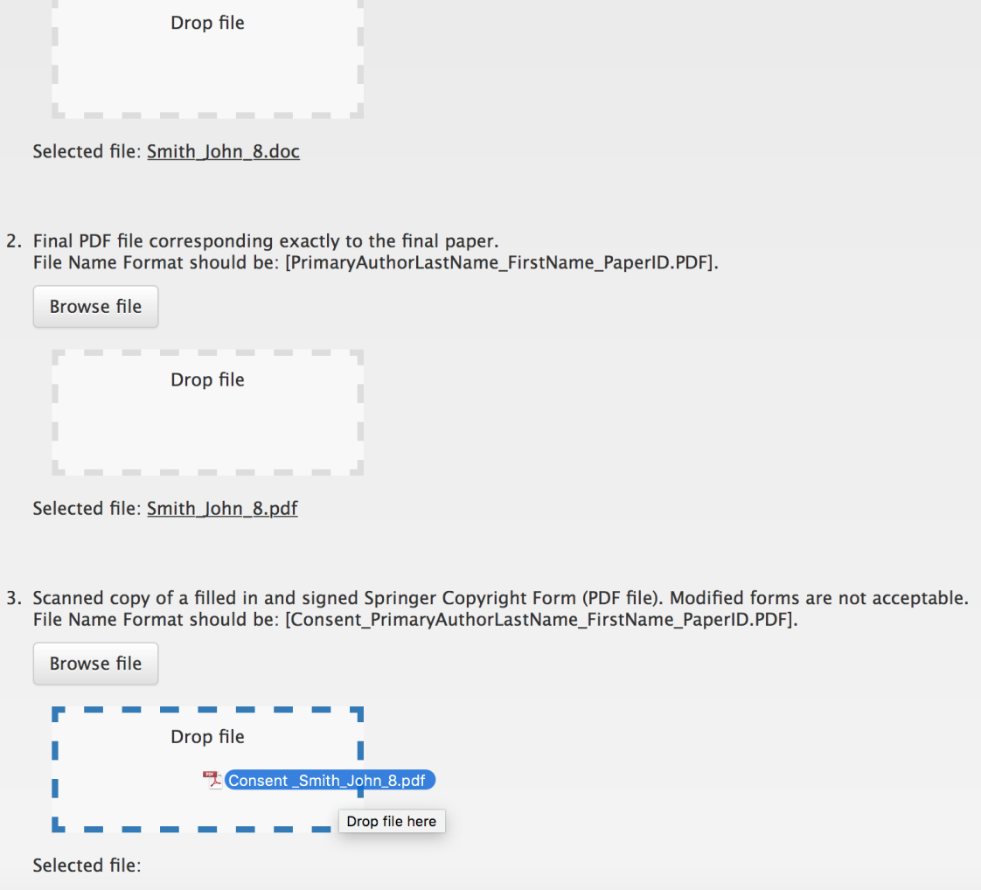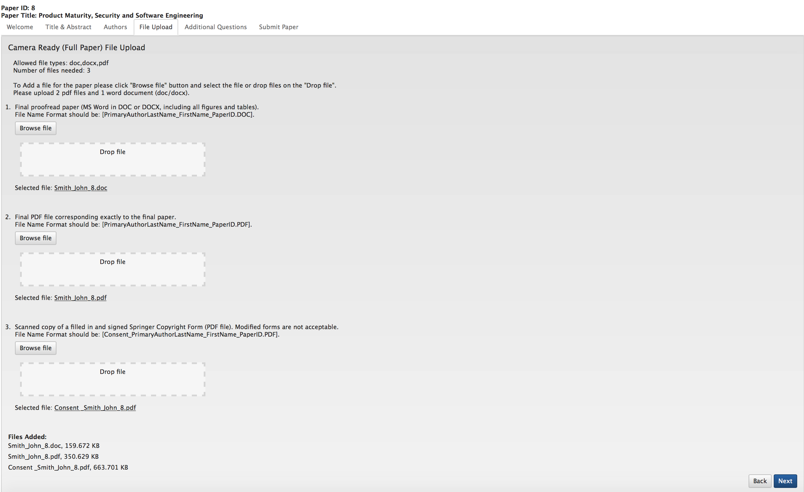

**Drag file from computer to box**

**Click “Next” to proceed**

**Upload signed consent form (.pdf )**

**Upload final paper proof (.pdf )**

**Upload final paper (.dox or .docx)**

**Click “Browse” or Drag file to the box to upload your Camera-Ready (Final Paper) files.**

**Important Note:**

**Please upload/submit your Camera Ready formatted paper (The recommended page size of full papers is 6 pages and the maximum is 8 pages) in the AHFE Submission system (**[**https://www.ahfe-cms.org**](https://www.ahfe-cms.org)**). Questions? Please contact AHFE Administrator** [**admin@ahfe.org**](mailto:admin@ahfe.org)

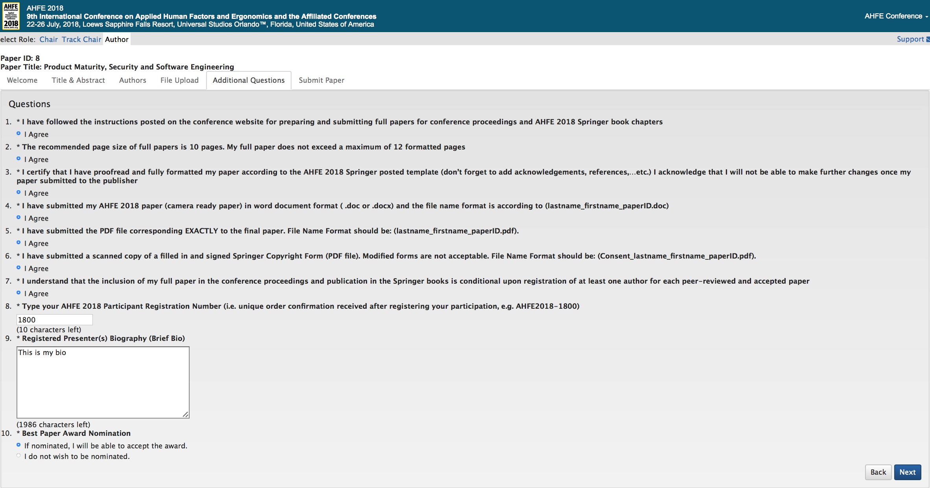

**Author Questions**

**John Smith**

**Click “Next” to proceed**

**Important Note:**

**Please upload/submit your Camera Ready formatted paper (The recommended page size of full papers is 6 pages and the maximum is 8 pages) in the AHFE Submission system (**[**https://www.ahfe-cms.org**](https://www.ahfe-cms.org)**). Questions? Please contact AHFE Administrator** [**admin@ahfe.org**](mailto:admin@ahfe.org)

**John Smith**

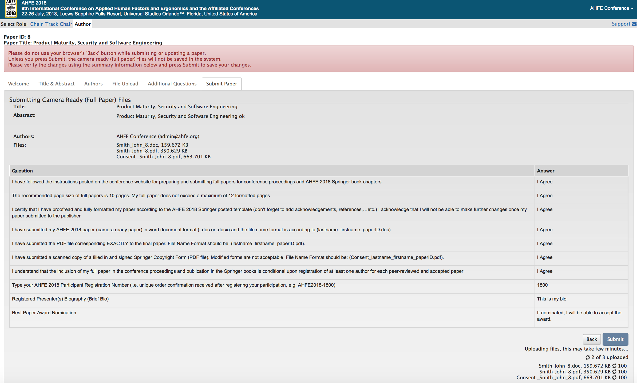

**Click “Submit” to Upload Files and Submit Full Paper**

***File upload may take few minutes depending on file size and your internet speed!***

**Author Questions**

xx

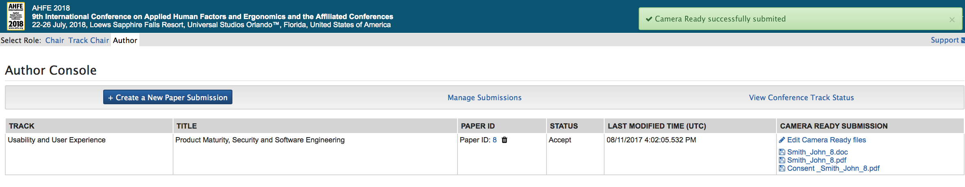

**Important Note:**

**Please upload/submit your Camera Ready formatted paper (The recommended page size of full papers is 6 pages and the maximum is 8 pages) in the AHFE Submission system (**[**https://www.ahfe-cms.org**](https://www.ahfe-cms.org)**).**

**Questions? Please contact AHFE Administrator** [**admin@ahfe.org**](mailto:admin@ahfe.org)

**How Can I find my Paper ID ?**

If you have submitted an abstract through the system before then Log in to: (<https://www.ahfe-cms.org>) to find your submission “Paper ID”

***If you haven’t submitted an abstract through the system or assigned a Paper ID previously then after you log in select “Create a new Paper Submission” to obtain a Paper ID.***

**Camera Ready (Full Paper) Submission Confirmation Message!**