Marcus Schmidt (Corresponding author)

Marcus studied mathematics and physical education at TU Dortmund University. Since finishing his degree (M.Ed.) in 2011 he works as a scientific employee at the institute for sport and sport science at TU Dortmund University. He will finish his phd this summer and his thesis is about the use of inertial measurement systems for jumping and sprinting diagnosis in track and field. Marcus main research interests are the use of sensor technology for in-field diagnosis of jumping and sprinting in several sports (track and field, volleyball, basketball, handball), as well as underlying aspects of motor learning.

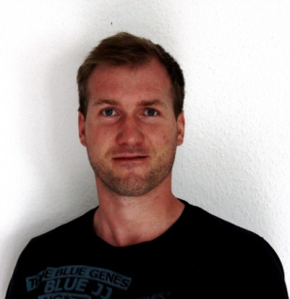

Sebastian Wille

Dipl.-Ing. Sebastian Wille joined 2010 the Microelectronics Systems Design Research Group of Prof. Wehn at TU Kaiserslautern. His research is about design and evaluation of Internet of things applications based on Wireless Sensor Networks. In his studies of electrical and information technology he won a prize from Richard-Hirschmann-Stiftung for "prominent study achievement" and the Klara-Röser prize "for notably scientific work". 2005 he won the third prize of german-wide Young Researcher competition in the area of technology. Begin 2016 he founded Wille Engineering, a company providing IT and electronic services.

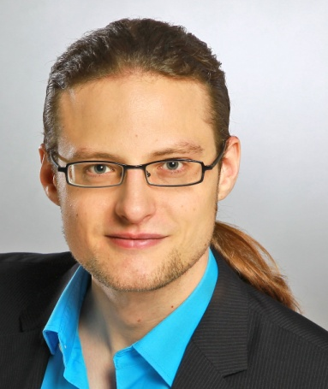

Carl Christian Rheinländer

M. Eng. Carl C. Rheinländer joined the Microelectronics Systems Design Research Group of Prof. Wehn at TU Kaiserslautern in 2015. His research is about embedded ultra low power hardware designs and communication technologies for distributed interconnected systems.

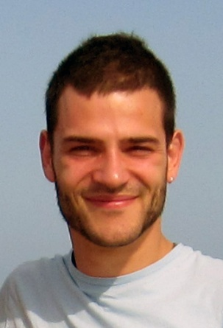

Norbert Wehn

Norbert holds the chair for Microelectronic System Design in the department of Electrical Engineering and Information Technology at the University of Kaiserslautern. He has more than 250 publications in various fields of microelectronic system design and holds several patents. Two start-ups spinout of his research group. He is Vice-President of the University Kaiserslautern, associate editor of various journals and member of several scientific advisory boards. In 2003 he served as program chair for DATE 2003 and as general chair for DATE 2005 respectively. In 2014 he was general Co-Chair of FPL 2015. His special research interests are VLSI-architectures for mobile communication, forward error correction techniques, low-power techniques, advanced SoC and memory architectures, 3D integration, reliability issues in SoC and hardware accelerators for financial mathematics and big data applications.

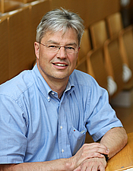

Thomas Jaitner

Thomas Jaitner is professor for movement and training science at the TU Dortmund and head of the sections “Movement and Training” as well “Performance and Health”. Till 2016, he also was director of the Institute of Sports and Sports Science in Dortmund. Before he went to Dortmund, he was working at the Universities of Kaiserslautern, Leipzig and Frankfurt. His research focus is on the analysis of complex movement patterns and gross motor learning as well as on the development and application of wearable computing technologies for sports performance analysis.

